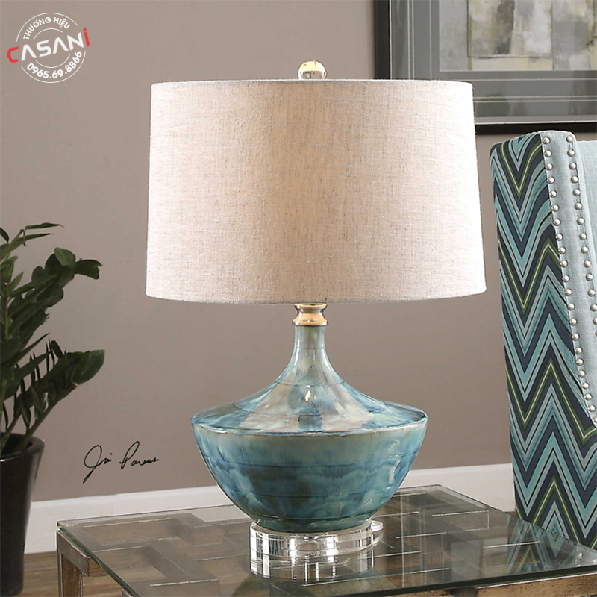

$106.25

Decorative table lamp DDB-2032

- Product name: Decorative table lamp

- Product code: DDB-2032

- Material: lamp body made of natural stone, fabric shade

- Design: modern

- Size: 55cm x 35cm

- Bulb type: LED or incandescent (can be easily purchased on the market)

- Status: In stock

- Warranty: 12 months

- Application: in work, study, interior decoration,...